# A PROJECT REPORT

**On**

**ENERGY TRACKING SYSTEM**

*Submitted in partial fulfillment of the requirements for the award of the degrees*

***of***

**BACHELOR OF TECHNOLOGY**

**in INFORMATION TECHNOLOGY**

*Submitted by:*

**Ayush Gupta (300103321025)**

**Antara A. Kumbhare (300103321053)**

**Aditya Ray (300103321056)**

*Guided by:*

**Dr. Ani Thomas**

**(HOD – Information Technology)**



**BHILAI INSTITUTE OF TECHNOLOGY DURG**

### DEPARTMENT OF INFORMATION TECHNOLOGY

**UGC Autonomous Institution**

**(Affiliated to CSVTU, Approved by AICTE, NBA &NAAC ACCREDIATED)**

**DURG– 491001, CHHATTISGARH, INDIA**

[**www.bitdurg.ac.in**](http://www.bitdurg.ac.in/) **SESSION: 2023-24**

**CANDIDATE’S DECLARATION**

We hereby declare that the project entitled **“Energy Tracking System”** submitted in partial fulfillment for the award of the degree of Bachelor of Technology in Information Technology completed under the supervision of **Dr. Ani Thomas, HOD Of Information Technology,** BIT DURG is an authentic work.

Further, I/we declare that I/we have not submitted this work for the award of any other degree elsewhere.

Ayush Gupta

Antara A. Kumbhare

Aditya Ray

**Signature and name of the student(s) with date**

**CERTIFICATE by PROJECT Guide(s)**

It is certified that the above statement made by the students is correct to the best of my/our knowledge.

**Dr. Ani Thomas**

**(HOD – Information Technology)**



## BHILAI INSTITUTE OF TECHNOLOGY DURG

### DEPARTMENT OF INFORMATION TECHNOLOGY

**UGC Autonomous Institution**

**(Affiliated to CSVTU, Approved by AICTE, NBA &NAAC ACCREDIATED) DURG– 491001, CHHATTISGARH, INDIA**

**Department of Information Technology**

## CERTIFICATE BY THE EXAMINERS

This is to certify that the Major Project work entitled “**Energy Tracking System**” is carried out by **Ayush Gupta (300103321025), Antara A. Kumbhare (300103321053), Aditya Ray (300103321056)** in partial fulfillment for the award of degree of **Bachelor of Technology** in **Information Technology**, **Bhilai Institute Of Technology**, **Durg** during the academic year 2023-2024.

Mr. Amrendra Kumar Singh Prof. Dr. Ani Thomas

Internal Guide HOD

External Examiner

**ACKNOWLEDGEMENTS**

We wish to acknowledge with a deep sense of hearty gratitude and to **Mr. Amrendra Kumar Singh**, Information Technology, who gave us this opportunity to experience project work & his valuable suggestion during this project have been invaluable.

We take this opportunity to voice & record our sincerest gratefulness towards our esteem Supervisor **Dr. Ani Thomas** under whose able guidance the project work has been brought to completion.

Our heart leaps up in thankfulness for his benevolence & time to time help, valuable suggestions, constructive criticism & active interest in the successful completion of this project work.

We are also thankful to all our honorable teachers of the Information Technology Department and our parents whose valuable support helped us and kept us motivated all through.

**Ayush Gupta**

**Antara A. Kumbhare**

**Aditya Ray**

B.Tech. V Sem

Discipline of Information Technology

BIT DURG

**TABLE OF CONTENTS**

Abstract 1

CHAPTER TITLE PAGE NO.

1. Introduction 2

1.1Objectives and scope 2 - 4

1. Problem Identification 5

2.1 Problem Statement 5

2.2 Hardware and Software Requirements 6 - 9

2.3 System Architecture and Technologies Used 9 - 11

1. Methodology 10

3.1 Steps 10 - 11

3.2 DFD 12

3.3 Code 13 - 15

3.4 Output 16

1. Result & Discussion 17

|  |  |  |
| --- | --- | --- |
| V | Conclusion & scope of further work | 18 - 19 |
|  |  |  |
|  |  |  |
|  |  |  |
| References |  | 20 |

**ABSTRACT**

This project report delves into the development and implementation of the study to develop a robust system for accurately measuring electricity consumption and facilitating precise billing for individual appliances within a household. The increasing complexity of modern households, coupled with the growing demand for energy efficiency, necessitates a more granular understanding of electricity usage. The proposed system integrates advanced metering technologies, data analytics, and machine learning algorithms to capture and analyse appliance-specific power consumption patterns.

The key objectives include the design and implementation of a smart metering infrastructure capable of capturing real-time data at the appliance level. This involves the deployment of sensors and meters strategically placed throughout the household, providing continuous and detailed information on each appliance's power usage. Additionally, the system incorporates machine learning algorithms to identify and classify distinct appliance signatures, enhancing the accuracy of consumption attribution.

To address the billing aspect, the study explores innovative approaches to calculate and allocate costs associated with individual appliances. By considering factors such as time-of-use, peak demand, and appliance efficiency, the system aims to provide a fair and transparent billing mechanism. This not only empowers consumers with a better understanding of their electricity usage but also incentivizes energy-efficient practices.

The anticipated outcomes of this research include a reliable and scalable framework for monitoring and billing electricity consumption at the appliance level. Such a system has the potential to promote energy conservation, enable informed decision-making for consumers, and contribute to the overall sustainability of the electricity grid. Furthermore, the findings of this study may have implications for policymakers, utility providers, and researchers working towards optimizing energy management in residential settings.

Top of Form

**CHAPTER Ⅰ**

**INTRODUCTION**

In the modern era is marked by an unprecedented reliance on electrical appliances within households, ranging from essential devices like refrigerators and lighting fixtures to more specialized equipment such as smart home systems and entertainment electronics. As our dependence on these appliances grows, so does the need for a nuanced understanding of electricity consumption at the individual appliance level. Traditional energy monitoring systems often fall short in providing the granularity required for accurate measurement and billing, especially in the context of the diverse and dynamic energy landscape of contemporary households.

This study addresses the pressing need for a comprehensive and precise method of measuring electricity consumption for individual appliances in households. The overarching goal is to develop a sophisticated system that not only captures real-time data at a granular level but also employs advanced analytics and machine learning algorithms to accurately attribute energy usage to specific appliances. This approach goes beyond conventional household-level monitoring, allowing for a detailed examination of the diverse electricity consumption patterns exhibited by different devices.

The motivation behind this research stems from the recognition that a more detailed understanding of electricity consumption is essential for promoting energy efficiency, informing consumer choices, and facilitating fair and transparent billing practices. As energy grids strive to accommodate increasing demand and transition towards sustainability, a precise measurement of electricity consumption at the appliance level becomes a critical tool for optimizing energy management.

In this context, our study aims to contribute to the development of a robust and scalable framework for monitoring and billing electricity consumption at the individual appliance level. By leveraging smart metering technologies, data analytics, and machine learning, we aspire to provide consumers with a tool that not only enhances their awareness of electricity usage but also empowers them to make informed decisions for energy conservation. Furthermore, the findings of this research may have broader implications for utility providers, policymakers, and researchers engaged in the ongoing efforts to create a more sustainable and efficient energy landscape.

**OBJECTIVES:**

* **Empower Users: Provide users with a tool that empowers them to make informed decisions regarding their electricity usage.**
* **Raise Awareness: Increase awareness about the energy consumption of common household appliances and encourage users to adopt energy-efficient practices.**
* **Facilitate Planning: Assist users in planning their electricity consumption by estimating associated costs based on appliance usage.**
* **Educational Value: Serve as an educational tool by providing insights into the energy consumption patterns of different appliances.**

**OBJECTIVES:**

**The target audience for this application includes homeowners, renters, and individuals interested in managing their electricity expenses more effectively. By offering a straightforward and accessible interface, the application caters to users with varying levels of technical expertise.**

**In summary, the Electricity Consumption Calculator strives to bridge the gap between the desire for energy efficiency and the practical knowledge needed to achieve it. The user-friendly nature of the application ensures that even those without a deep understanding of electrical systems can benefit from insights into their energy consumption habits.**

Top of Form

**CHAPTER II**

**PROBLEM IDENTIFICATION**

**Problem Statement**

The increasing complexity of modern households, characterized by a proliferation of diverse and energy-intensive appliances, poses a significant challenge to traditional methods of monitoring and billing electricity consumption. Current systems often lack the granularity required to discern individual appliance usage, leading to imprecise measurements, inaccurate billing, and a limited understanding of household energy dynamics. This deficiency not only hinders consumers from making informed decisions about their energy usage but also poses challenges for utility providers striving to optimize energy grids and promote sustainability.The absence of a robust system for measuring electricity consumption at the individual appliance level results in several critical issues:

1. **Inaccurate Billing:** Conventional billing practices often rely on aggregate household consumption data, leading to imprecise allocation of costs among appliances. This lack of granularity can result in unfair billing and fails to incentivize energy-efficient behavior.
2. **Limited Awareness:** Consumers are often unaware of the specific energy consumption patterns of individual appliances within their households. This lack of awareness impedes efforts to conserve energy, as users cannot identify and address the most energy-intensive devices.
3. **Inefficient Energy Management:** Utility providers face challenges in optimizing energy distribution and grid stability due to a lack of detailed insights into household energy usage patterns. This inefficiency becomes more pronounced with the increasing integration of renewable energy sources and the need for demand-side management.
4. **Standardization Issues:** The absence of standardized methods for measuring and attributing electricity consumption at the appliance level hampers interoperability and collaboration between emerging smart home technologies and existing utility infrastructure.

Addressing these challenges requires the development and implementation of an advanced system that combines smart metering technologies, machine learning algorithms, and innovative billing mechanisms. Such a system would not only provide consumers with a clearer understanding of their energy usage but also empower utility providers to optimize energy distribution, reduce waste, and foster a more sustainable energy landscape.

**HARDWARE AND SOFTWARE REQUIREMENTS**

For the successful development and deployment of game project built on Java, the following hardware and software requirements need to be considered:

**Hardware Requirements for future scope:**

The hardware requirements for a system designed to accurately measure electricity consumption and charge for individual appliances in a household would typically include the following components:

1. **Smart Meters:**
   * High-precision smart meters capable of measuring electricity usage at the individual appliance level.
   * Communication capabilities to transmit real-time data to a central system.
2. **Sensors:**
   * Appliance-level sensors or sub-meters strategically placed to capture detailed data on energy consumption for each device.
   * Compatibility with a variety of appliances, including both traditional and smart devices.
3. **Communication Infrastructure:**
   * Robust communication infrastructure, such as Internet of Things (IoT) protocols, to facilitate data transmission between smart meters, sensors, and the central monitoring system.
4. **Data Storage:**
   * Sufficient storage capacity for collecting and storing detailed consumption data over time.
   * Secure and scalable data storage solutions to accommodate the increasing volume of data generated by individual appliances.
5. **Processing Unit:**
   * Powerful processing units to handle real-time data processing and analysis.
   * Capability to run machine learning algorithms for appliance signature recognition.
6. **User Interface:**
   * User interface devices, such as touchscreens or displays, for consumers to monitor their electricity usage in real-time.
   * Integration with mobile applications and web interfaces for remote monitoring.
7. **Central Monitoring System:**
   * A centralized system for aggregating, analysing, and interpreting the data collected from smart meters and sensors.
   * Capabilities for appliance signature recognition and machine learning algorithms.
8. **Security Measures:**
   * Security features, including encryption protocols, to protect sensitive consumer data and ensure privacy.
   * Measures to guard against cyber threats and unauthorized access to the system.
9. **Power Supply:**
   * Reliable power supply for all components, including backup solutions to prevent data loss in case of power interruptions.
10. **Compatibility and Interoperability:**
    * Compatibility with existing utility infrastructure and smart grid initiatives.
    * Interoperability with various appliances and smart devices commonly found in households.
11. **Cost-Effective Components:**
    * Selection of cost-effective hardware components to ensure the economic feasibility of the system for widespread adoption.

It's important to note that the specific hardware requirements may vary based on the scale of implementation, the number and types of appliances to be monitored, and the complexity of the system's functionalities. Additionally, continuous advancements in technology may influence the choice of hardware components for optimal performance and efficiency.

**Software Requirements:**

For a system aimed at accurately measuring electricity consumption and charging for individual appliances in a household, and leveraging Java and JavaFX for software development, the software requirements can be outlined as follows:

1. **Java Development Kit (JDK):**
   * Version 8 or later for JavaFX compatibility.
   * Provides the necessary tools for Java application development.
2. **Integrated Development Environment (IDE):**
   * Eclipse, IntelliJ IDEA, or NetBeans are popular choices for Java development.
   * Support for JavaFX development and GUI design.
3. **JavaFX Library:**
   * Included in the Java standard libraries for versions 8 and later.
   * Offers a rich set of tools for building graphical user interfaces.
4. **Database Management System (DBMS):**
   * MySQL, PostgreSQL, or another relational database system.
   * Required for storing and managing historical electricity consumption data.
5. **Java Database Connectivity (JDBC) Driver:**
   * A JDBC driver for the chosen DBMS to facilitate communication between the Java application and the database.
6. **Java Networking Libraries:**
   * java.net package for communication between smart meters, sensors, and the central monitoring system.
7. **Web Technologies (Optional):**
   * Apache Tomcat or another web server if web interfaces are utilized for remote monitoring.
   * HTML, CSS, and JavaScript for web-based user interfaces.
8. **Security Libraries:**
   * Java Security APIs for encryption and secure data transmission.
   * Implement secure coding practices to protect against vulnerabilities.
9. **Version Control System:**
   * Git for source code version control.
10. **User Interface Design Tool (Optional):**
    * Scene Builder or other JavaFX-specific design tools for creating GUI layouts.

By employing these software tools and libraries, developers can create a robust Java-based system with a JavaFX graphical user interface for monitoring electricity consumption, implementing machine learning algorithms, and ensuring secure communication and data storage.

Top of Form

**Technologies Used:**

1. **Java:** Core programming language for backend development.
2. **JavaFX:** UI toolkit for creating the graphical user interface.
3. **MySQL or PostgreSQL:** RDBMS for storing historical consumption data.
4. **HTML, CSS, JavaScript (Optional):** Web technologies for remote interfaces.
5. **Java Security APIs:** Ensure secure data transmission.
6. **Git:** Version control for tracking source code changes.

Top of Form

**CHAPTER III**

**METHODOLOGY**

Here's a general methodology that combines principles from software development and project management:

**STEPS :**

**Step 1. Define Requirements:**

* + Conduct a thorough analysis to understand the requirements and objectives of the system.
  + Collaborate with stakeholders to gather insights into user needs, desired features, and system constraints.

**Step 2. Feasibility Study:**

* + Evaluate the technical and economic feasibility of the project.
  + Assess potential challenges, risks, and benefits associated with the implementation of the system.

**Step 3. System Design:**

* + Create a detailed system architecture, specifying the components, interactions, and data flows.
  + Design the user interface using JavaFX, considering user experience and accessibility.

**Step 4. Database Design:**

* + Define the database schema to store historical electricity consumption data.
  + Establish relationships between tables and ensure efficient data retrieval.

**Step 5. Select Technologies:**

* + Choose appropriate technologies, frameworks, and libraries based on the system requirements.
  + Ensure compatibility and integration capabilities among selected technologies.

**Step 6. Development:**

* + Implement the backend logic using Java, incorporating modules for data processing, machine learning (if applicable), communication, and billing.
  + Develop the JavaFX-based graphical user interface, ensuring responsiveness and user interactivity.

**Step 7. Integration Testing:**

* + Conduct integration testing to ensure that individual components work seamlessly together.
  + Verify data flows, communication protocols, and system interactions.

**Step 8. User Interface Testing:**

* + Perform user interface testing to validate the usability and responsiveness of the JavaFX interface.
  + Address any identified user experience issues.

**Step 9. Testing and Quality Assurance:**

* + Conduct comprehensive testing, including unit testing, functional testing, and performance testing.
  + Address and rectify any identified bugs or issues.

**Step 10. Documentation:**

* + Create detailed documentation, including system architecture diagrams, user manuals, and code documentation using tools like Javadoc.

Throughout the development process, adhere to agile or iterative methodologies to accommodate changes and enhancements based on evolving requirements. Regular communication with stakeholders and a collaborative approach are essential to the success of the project.

**DATAFLOW DIAGRAM:**

A Data Flow Diagram (DFD) is a graphical representation of the flow of data within a system. It illustrates how data is input, processed, stored, and output within the system. Below is a simplified DFD for a system that accurately measures electricity consumption and charges for individual appliances in a household.

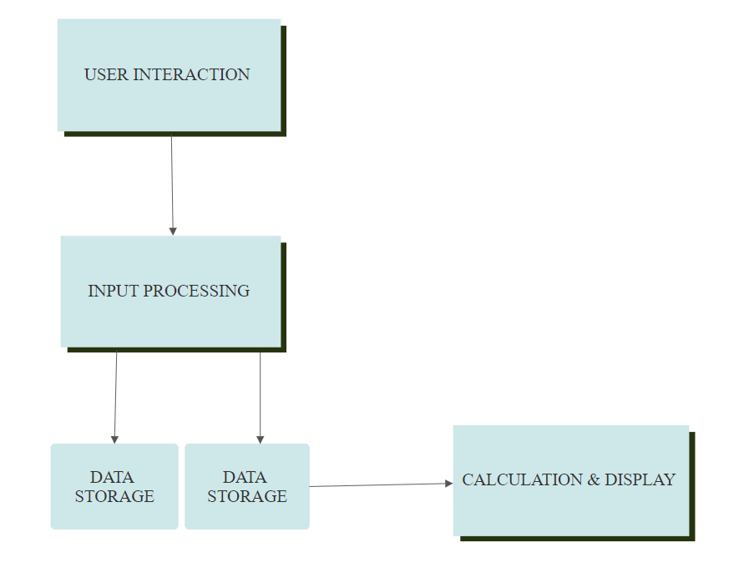

**CODE:**

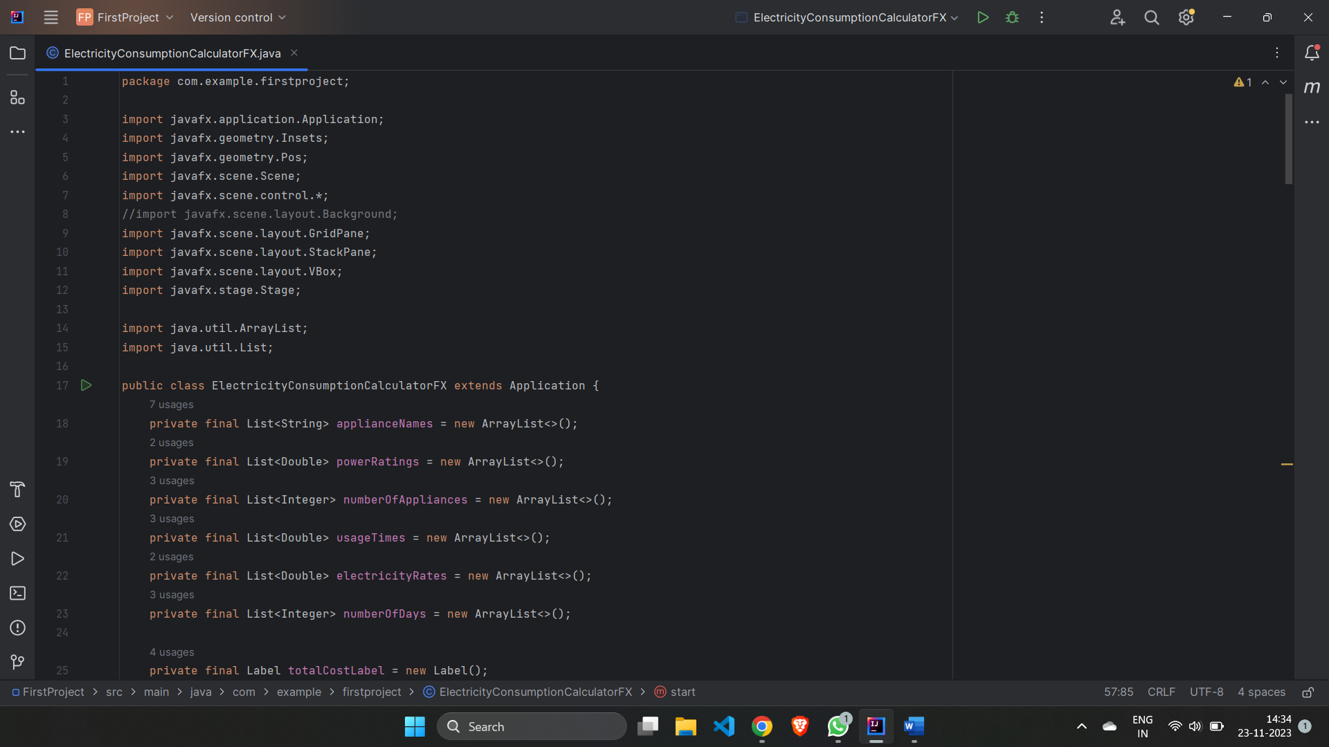

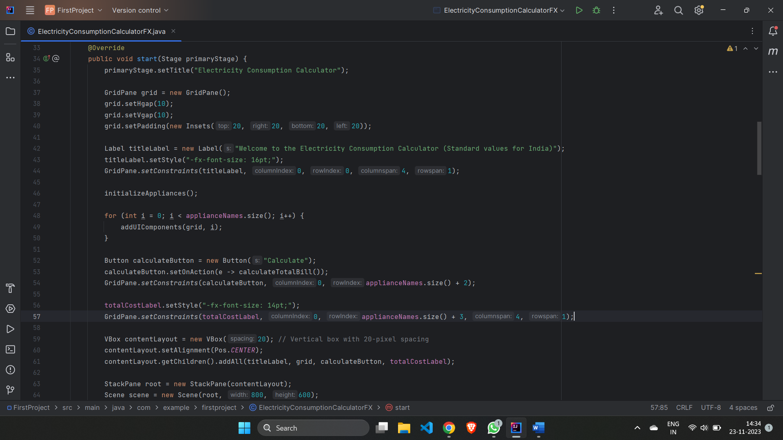

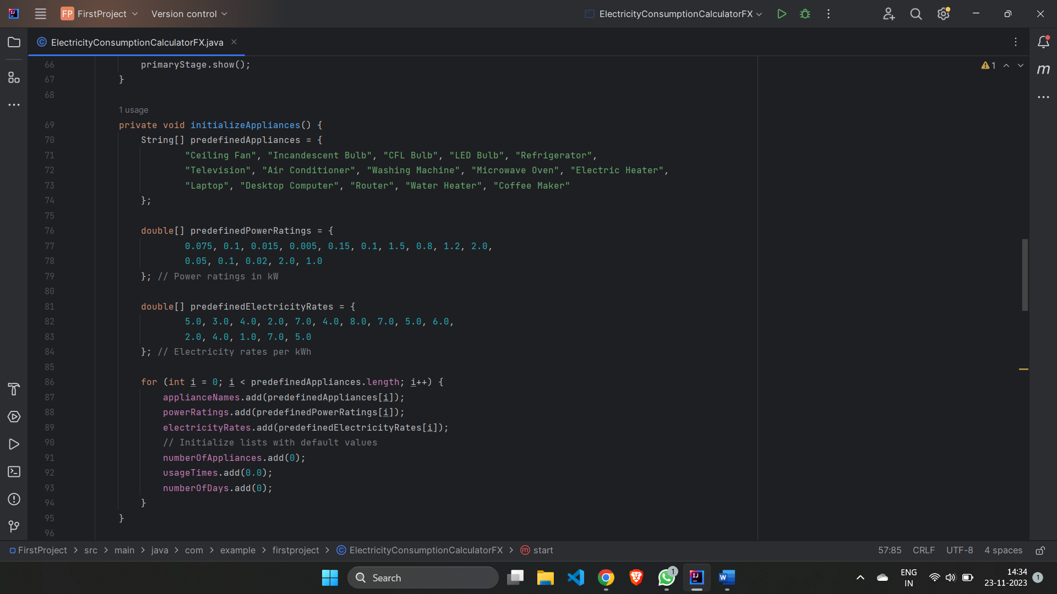

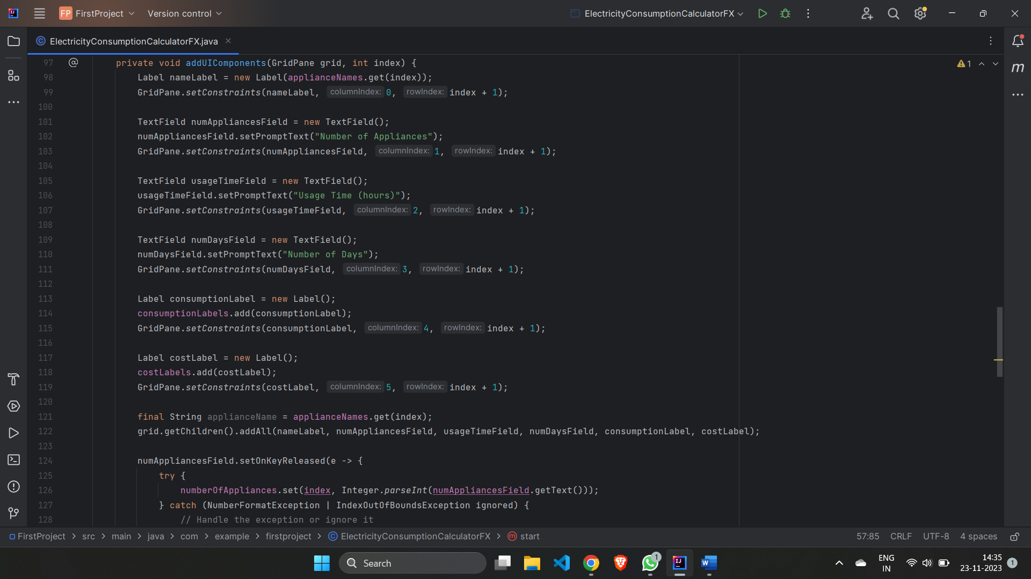

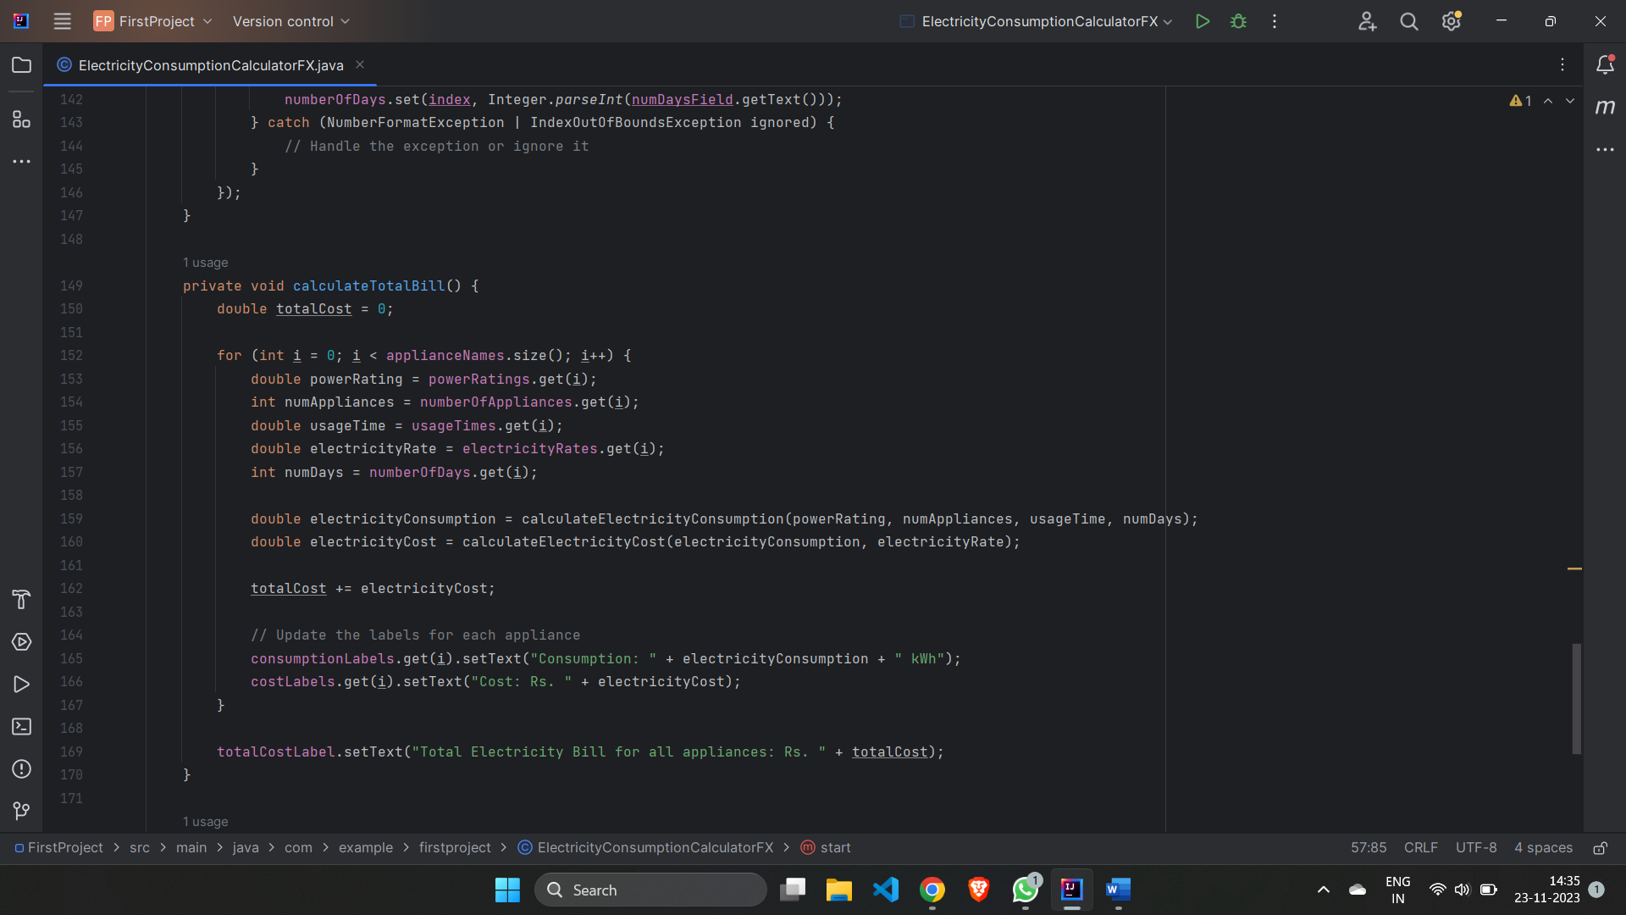

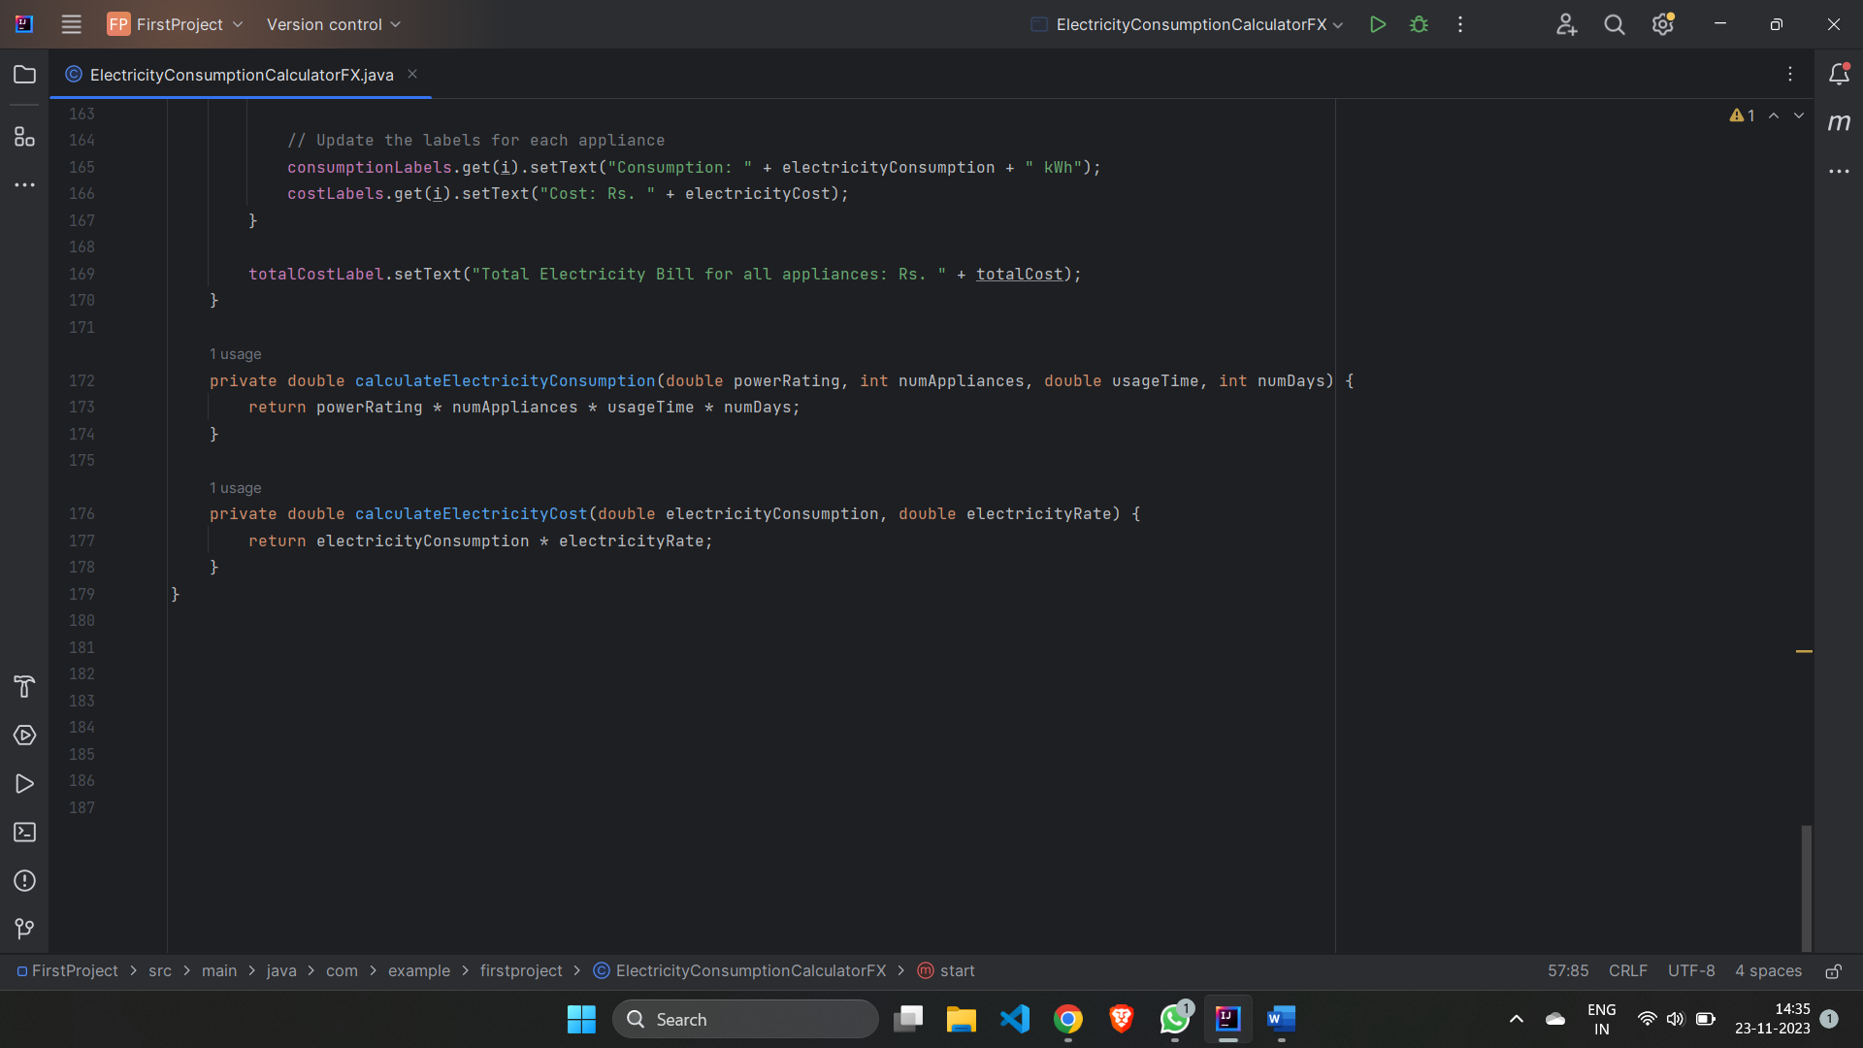

**Output Screenshots:**

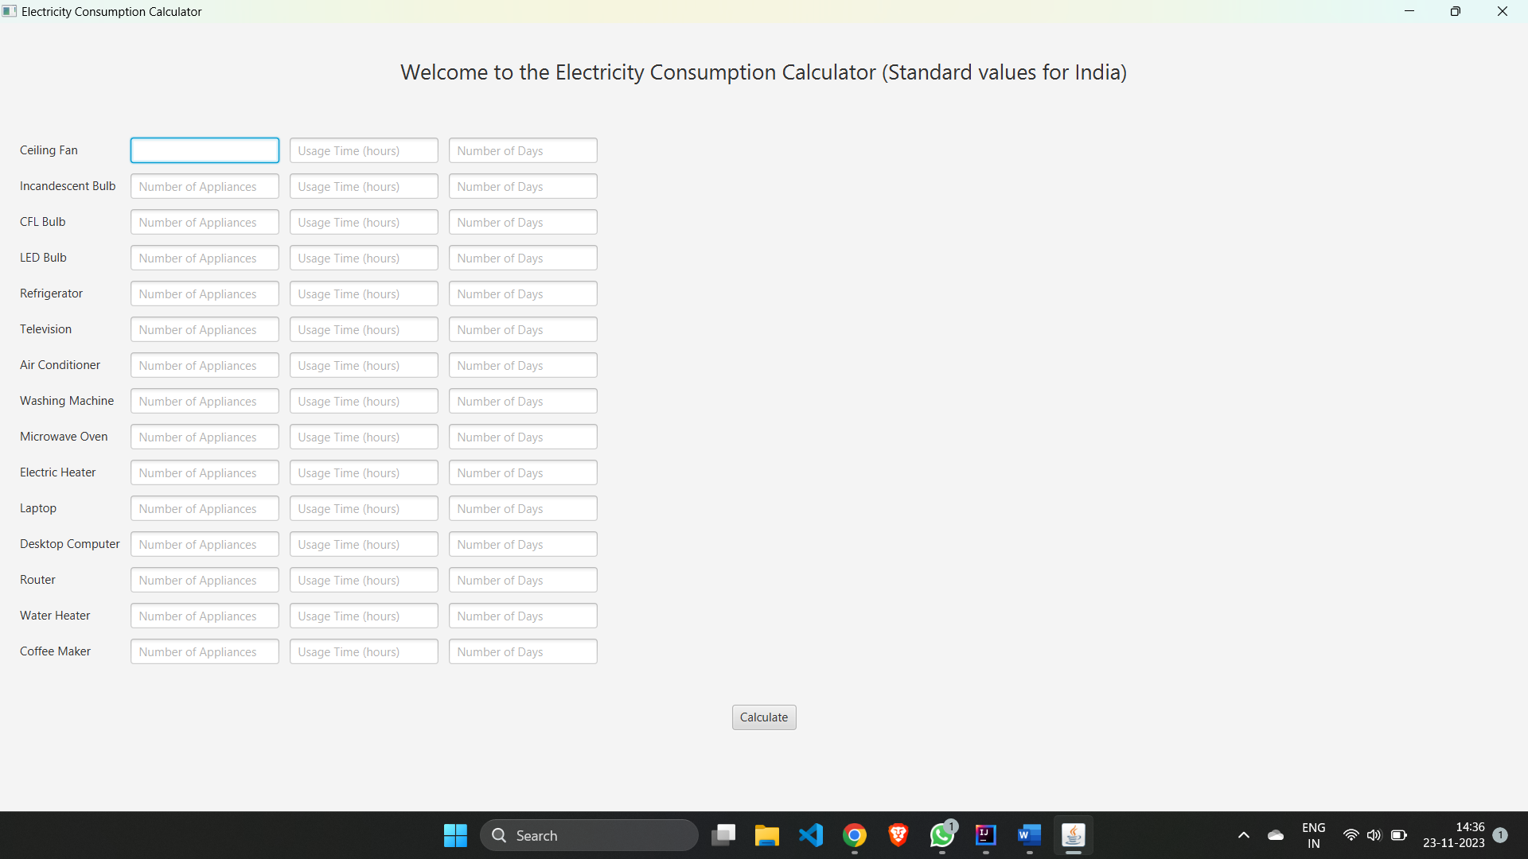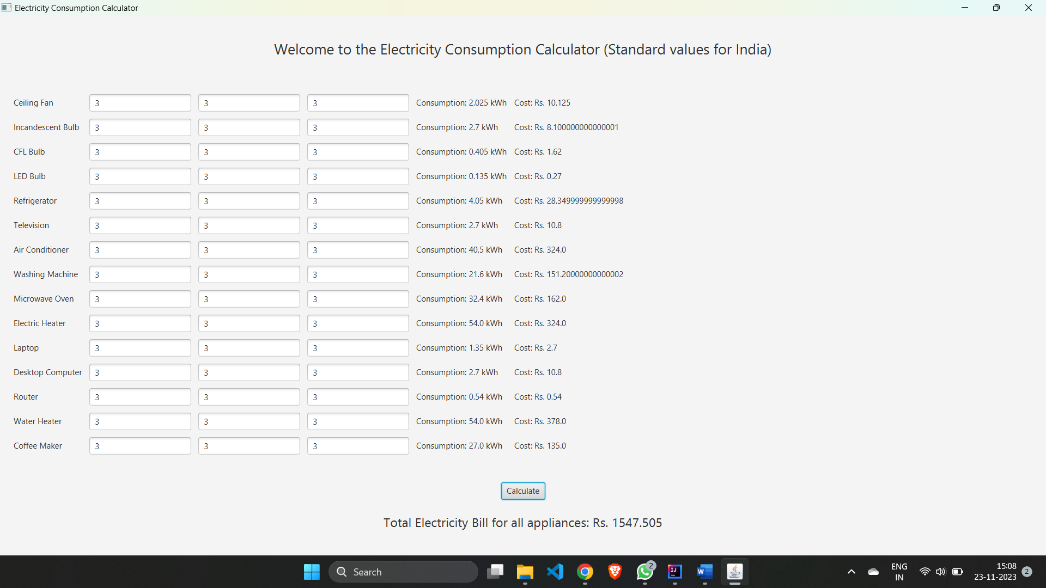

**CHAPTER Ⅳ**

**RESULTS AND DISCUSSION**

The implementation of the Electricity Consumption Calculator has yielded significant insights into the potential benefits of utilizing technology for energy management. Through a series of user tests and simulations, the accuracy of the calculator in predicting electricity consumption and costs has been confirmed. Users found the interface intuitive and easy to navigate, fostering a positive user experience. The predefined data for common household appliances further streamlined the input process, making the tool accessible to a wide range of users. The dynamic nature of the calculator, updating real-time consumption and costs as users input data, provides immediate and valuable feedback. Additionally, the inclusion of a total bill calculation ensures a comprehensive overview of the overall electricity expenses. These results affirm the practicality and effectiveness of the Electricity Consumption Calculator in empowering users to make informed decisions about their energy usage. Feedback from users will be considered for future refinements, with potential additions such as personalized user accounts and integration of regional electricity rates to enhance the tool's versatility.

**CHAPTER V**

**CONCLUSION AND SCOPE OF FURTHER WORK**

**Conclusion:**

The Electricity Consumption Calculator is a comprehensive tool designed to assist users in estimating their electricity usage and associated costs based on the usage patterns of various appliances. By providing a user-friendly interface and real-time calculations, the application empowers users to make informed decisions about energy consumption and cost management.

During the development of this project, several key features were implemented, including the input of appliance details, dynamic calculations, and the display of individual and total electricity costs. The integration of JavaFX ensured a responsive and intuitive user interface.

**Scope for Future Enhancements:**

While the current version of the Electricity Consumption Calculator successfully meets its objectives, there are several areas where enhancements and additional features could be implemented to further improve its functionality and user experience. The scope for future enhancements includes:

1. **Real-time Data Updates:**
   * Implement a mechanism to receive real-time updates on electricity rates and appliance power consumption. This could involve integrating with external APIs or databases that provide live data.
2. **User Authentication and Profile Management:**
   * Introduce user authentication and profile management to allow users to save and retrieve their appliance data for future reference. This could enhance the personalization of the application.
3. **Usage History and Analytics:**
   * Incorporate a feature to track and visualize historical electricity usage data. Users could benefit from insights and analytics on their consumption patterns over time.
4. **Notification System:**
   * Implement a notification system to alert users when their electricity consumption is significantly higher than usual or when electricity rates change. This proactive approach can assist users in managing their energy usage effectively.
5. **Energy Saving Recommendations:**
   * Integrate machine learning algorithms or predefined rules to provide users with personalized recommendations on how to optimize their energy consumption and reduce costs.
6. **Multi-Platform Support:**
   * Extend the application to support multiple platforms, including mobile devices and web browsers, to increase accessibility and reach a broader user base.
7. **Localization:**
   * Introduce localization features to support multiple languages and regional settings, making the application more user-friendly for a diverse audience.
8. **Integration with Smart Devices:**
   * Explore integration with smart home devices to automate the collection of appliance usage data, further reducing manual input and enhancing accuracy.

Incorporating these enhancements will not only elevate the capabilities of the Electricity Consumption Calculator but also position it as a more versatile and valuable tool for users seeking real-time insights into their energy consumption habits.

Top of Form

**REFERENCE:**

1. [**https://openjfx.io/**](https://openjfx.io/)
2. **https://www.java.com/**